**Lab-7**

**Hirenbhai Shah ID: 27**

**Dinesh Paduru ID : 19**

**Q1 and Q3**

We have merged this two question as I am taking output of 1st question and displaying it as a notification on smartwatch. We have done twitter streaming for doing sentiment analysis by using **StanfordcoreNLP** library. We have filter out tweets as per current presidential election to decide the sentiment of the user. As its rate on scale of 1 to 5 for negative to positive, in output I am showing tweets along with its category as a notification to the smart device. Below are the snap shots for it:

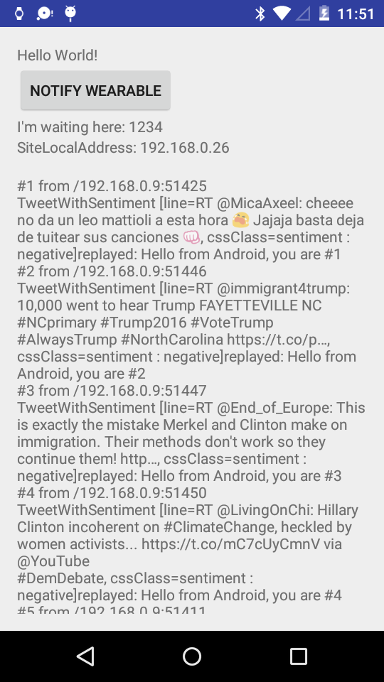

**SmartWear notification :**

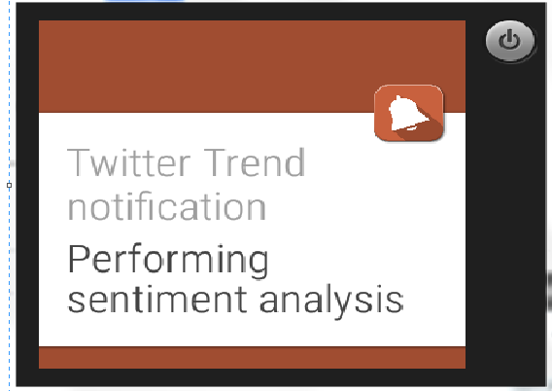

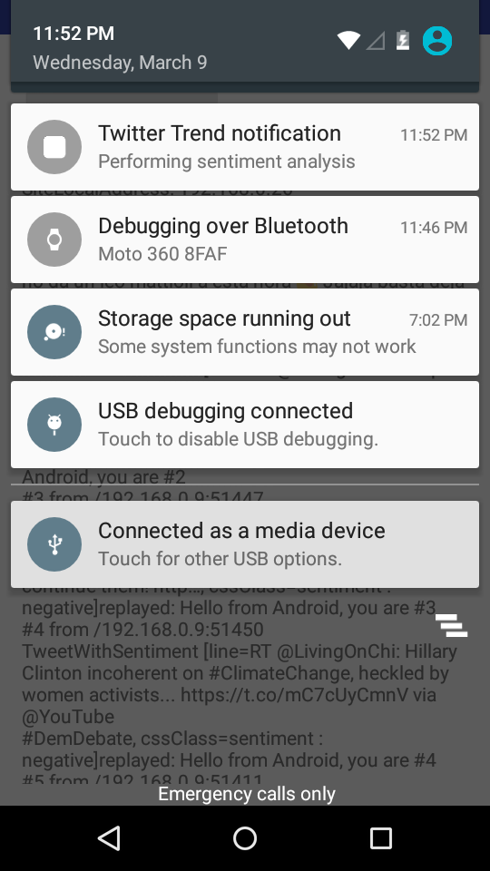

**Q2 and Q4**

We have worked on recommendation system for our project for recommending user diet and exercise on basis of his input. System asks user about his mood and how is he feeling right now? And according to that system will generate recommendation for him by comparing it with the existing dataset.